Chapter 4 Chemical Reactions name: class:
1. 掌握物理变化与化学变化的区别
Physical change: composition unchanged; only intermolecular forces are broken/formed (e.g. melting, boiling, dissolving)
Chemical change: new substances formed with different composition; chemical bonds (intramolecular) are broken/formed
Evidence of chemical change: heat/light evolved, gas produced (bubbles), precipitate formed, color change
Dissolving a salt can be considered both physical and chemical depending on the perspective

1. Which of the following is an example of a physical change? （ ）
A. Option A
B. Fermentation of grapes
C. Option C
D. Option D

2. Which of the following comparisons of chemical and physical processes is the most accurate? （ ）
A. Chemical and physical processes are characterized by changes in intramolecular forces.
B. Chemical and physical processes are characterized by changes only in intermolecular forces.
C. Chemical processes are characterized by changes in intramolecular forces, while physical processes are characterized by changes only in intermolecular forces.
D. Physical processes are characterized by changes in intramolecular forces, while chemical processes are characterized by changes only in intermolecular forces.

3. When two clear aqueous solutions are mixed, the resulting mixture becomes slightly cloudy but does not form a stable solid precipitate.
Gentle heating of the mixture restores its original clarity.
Which of the following statements best characterizes this observed change? （ ）
A. The cloudiness must represent a reversible chemical change, forming a precipitate that then dissolves upon heating.
B. The cloudiness indicates incomplete mixing and is purely physical since no reaction occurred.
C. The temporary cloudiness is a physical change since the original composition is restored by gentle heating.
D. The observed cloudiness must represent permanently formed new species, classifying it as a chemical change.

4. Which of the following best describes the change that takes place immediately after liquid ethanol is introduced into a previously evacuated vessel? （ ）
A. A chemical change takes place because covalent bonds are broken.
B. A chemical change takes place because intermolecular attractions are overcome.
C. A physical change takes place because covalent bonds are broken.
D. A physical change takes place because intermolecular attractions are overcome.

5. What of the following is a key characteristic of a chemical change? （ ）
A. New substances with different properties are formed.
B. The appearance of the substance changes.
C. The mass of the substance changes.
D. The state of matter changes.

6. Which observation best shows that a chemical change occurs when a colorless liquid and a blue liquid are combined? （ ）
A. The resulting mixture was cloudy, and its temperature increased.
B. The total volume of the mixture was equal to the sum of the initial volumes, but the blue color faded slightly.
C. The resulting liquid was uniformly light blue, and no other changes were observed.
D. The liquids formed two separate layers in the beaker after being stirred.

2. 掌握配平化学方程式与净离子方程式的书写
Balanced equation: same number of each atom on both sides; coefficients represent mole ratios
Net ionic equation: remove spectator ions (ions that appear unchanged on both sides)
Molecular equation → complete ionic → net ionic
Spectator ions: ions that do not participate in the reaction (same state, same charge)
Do not split: solids, gases, water, weak acids, weak bases

1. What is the net ionic equation for Zn(s) + 2 HCl(aq) → ZnCl₂(aq) + H₂(g)? （ ）
A Zn(s) + 2 HCl(aq) → ZnCl₂(aq) + H₂(g)
B Zn(s) + 2 H⁺(aq) → Zn²⁺(aq) + H₂(g)
C Zn(s) + 2 Cl⁻(aq) → ZnCl₂(aq)
D H⁺(aq) + Cl⁻(aq) → HCl(aq)

2. When aqueous Pb(NO₃)₂ and KI are mixed, a yellow precipitate forms. The spectator ions are: （ ）
A Pb²⁺ and I⁻
B K⁺ and NO₃⁻
C Pb²⁺ and NO₃⁻
D K⁺ and I⁻

3. Aqueous Pb(NO₃)₂ reacts with aqueous KI to produce a solid precipitate of PbI₂ and aqueous KNO₃.
Which of the following is the balanced net ionic equation for the reaction described above? （ ）
A. K+ (aq) + NO₃- (aq) → KNO₃(aq)
B. Pb(NO₃)₂ (aq) + 2I- (aq) → PbI₂ (s) + 2NO₃- (aq)
C. Pb₂+ (aq) + I- (aq) → PbI₂ (s)
D. Pb₂+ (aq) + 2I- (aq) → PbI₂ (s)

4. The diagram above shows a reaction between carbon monoxide and oxygen.
Which of the following equations best describes the reaction? （ ）
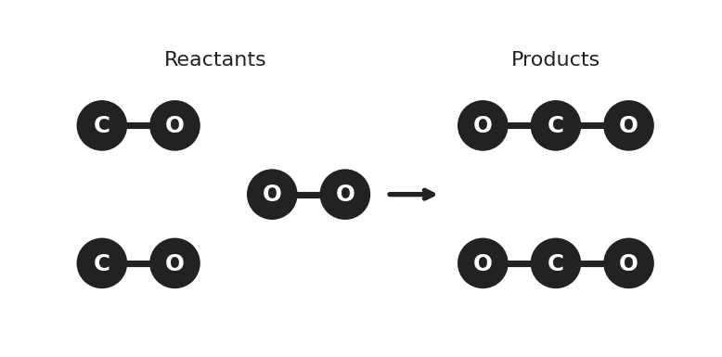
图 C₄-1：一氧化碳与氧气反应的粒子示意图（对应第 2 节 MCQ4，2CO + O₂ → 2CO₂）
A. C (g) + 2O₂ (g) → CO₂ (g)
B. 2CO (g) + O₂ (g) → 2CO₂ (g)
C. CO (g) + O₂ (g) → CO₂ (g)
D. 6CO (g) + 5O₂ (g) → 6CO₂ (g) + 2O₂ (g)

5. What is the balanced molecular equation when Na₂CO₃ (aq) is mixed with HCl (aq)? （ ）
A. Na₂CO₃ (aq) + 2HCl (aq) → 2NaCl (aq) + H₂O (l) + CO₂ (g)
B. Na₂CO₃ (aq) + HCl (aq) → Na₂Cl (aq) + H₂O (l) + CO₂ (g)
C. 2Na₂CO₃ (aq) + 2HCl (aq) → 2NaCl (aq) + H₂O (l) + CO₂ (g)
D. Na₂CO₃ (aq) + HCl (aq) → NaCl (aq) + H₂O (l) + CO₂ (g)

6. When the equation below is balanced, what is the mole ratio of CO₂ to H₂O? C₃H₅OH + O₂ → CO₂ + H₂O （ ）
A. Equation A
B. Equation B
C. Equation C
D. Equation D

7. Write balanced net ionic equations:
(a) Aqueous silver nitrate + aqueous sodium chloride → white precipitate. [2 marks]
(b) Solid magnesium + aqueous hydrochloric acid → hydrogen gas. [2 marks]
(c) Aqueous barium chloride + aqueous sodium sulfate. [2 marks]

3. 掌握常见化学反应类型
Precipitation reactions: two soluble ionic compounds mix → insoluble solid (precipitate) forms
Acid-base neutralization: H⁺ + OH⁻ → H₂O; may produce gas (e.g. carbonate + acid → CO₂)
Redox reaction: involves electron transfer — some atoms are oxidized (lose e⁻), some reduced (gain e⁻)
Oxidation: increase in oxidation number; Reduction: decrease in oxidation number
If no oxidation numbers change → NOT a redox reaction (e.g. acid-base, precipitation)
Combustion: substance reacts with O₂, producing CO₂ and H₂O (for hydrocarbons)
Synthesis (A + B → AB), Decomposition (AB → A + B), Single replacement (A + BC → AC + B), Double replacement (AB + CD → AD + CB)

1. For the reaction 2 Al(s) + 3 CuSO₄(aq) → Al₂(SO₄)₃(aq) + 3 Cu(s), which is correct? （ ）
A Al is reduced, Cu is oxidized.
B Al is oxidized, Cu is reduced.
C Both are oxidized.
D This is not a redox reaction.

2. Which reaction is NOT a redox reaction? （ ）
A 2 Na + 2 H₂O → 2 NaOH + H₂
B CaCO₃ + 2 HCl → CaCl₂ + CO₂ + H₂O
C 2 H₂O₂ → 2 H₂O + O₂
D Zn + CuSO₄ → ZnSO₄ + Cu

3. In the reaction 2 KClO₃ → 2 KCl + 3 O₂, what happens to Cl and O? （ ）
A Cl is oxidized; O is reduced.
B Cl is reduced; O is oxidized.
C Both are oxidized.
D Both are reduced.

4. Which of the following represents a redox reaction? （ ）
A. Fe + 2HCl → FeCl₂ + H₂
B. Diagram B — particle arrangement
C. K₂CO₃ + 2CH₃COOH → 2CH₃COOK + CO₂ + H₂O
D. ZnO + H₂SO₄ → ZnSO₄ + H₂O

5. H₂SO₄ (aq) + MgCO₃ (s) → MgSO₄ (aq) + H₂O (l) + CO₂ (g) Which of the following is a correct description of the above reaction? （ ）
A. Option A
B. Option B
C. neutralization with gas formation
D. Option D

6. What is the formula of the precipitate formed when zinc nitrate reacts with sodium carbonate? （ ）
A. Equation A
B. Equation B
C. Equation C
D. Equation D

7. What is the oxidation number of Cr in Cr(H₂O)₆₃+? （ ）
A. Option A
B. Option B
C. Option C
D. Option D

8. 3Cl₂ (g) + 6NaOH (aq) → 5NaCl (aq) + NaClO₃ (aq) + 3H₂O (l) Is the reaction represented above a redox reaction? （ ）
A. Yes, because chlorine is oxidized and oxygen is reduced.
B. Yes because chlorine is both oxidised and reduced.
C. Yes, because oxygen is oxidized and chlorine is reduced.
D. No, because none of the elements are oxidized or reduced.

9. 1 mol of a compound reacts with 9.5 mol of O₂ for complete combustion. What is the formula of the compound? （ ）
A. Equation A
B. Equation B
C. Equation C
D. Equation D

10. 3C₂H₅OH (l) + 2Cr₂O₇2- (aq) + 16H+ → 3CH₃COOH (l) + 4Cr₃+ (aq) + 11H₂O (l) Which element is reduced in the above reaction and how does its oxidation number change? （ ）
A. Cr; its oxidation number changes from -2 to +3.
B. Cr; its oxidation number changes from +6 to +3.
C. O; its oxidation number changes from -1 to 0.
D. O; its oxidation number changes from +1 to -2.

11. Isooctane, shown below, can be added to fuels for improved performance.
Which is the correct equation for the complete combustion of isooctane? （ ）
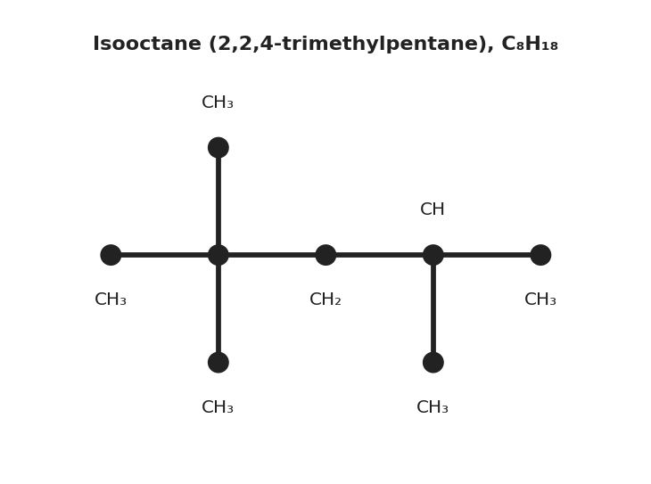
图 C₄-2：异辛烷（2,2,4-三甲基戊烷）碳骨架结构式（对应第 3 节 MCQ11，C₈H₁₈）
A. C₈H₁₈ + 8½O₂ → 8CO + 9H₂O
B. C₈H₁₈ + 12½O₂ → 8CO₂ + 9H₂O
C. C₇H₁₆ + 11O₂ → 7CO₂ + 8H₂O
D. C₈H₁₈ + 13O₂ → 8CO₂ + 9H₂O

12. Which of the following best describes the process represented above that takes place when Na₃PO₄ (aq) is added to CuCl₂ (aq)? （ ）
A. It is a single replacement reaction in which copper replaces sodium in the Na₃PO₄.
B. It is an neutralization reaction in which the salt Cu₃(PO₄)₂ is produced.
C. It is a precipitation reaction in which Cu₃(PO₄)₂, an insoluble solid, is produced.
D. It is an oxidation-reduction reaction in which the oxidation number of Cl changes from −1 to 0 .

13. For the reaction H₂O₂ → 2 H₂O + O₂:
(a) Assign oxidation numbers to oxygen in H₂O₂, H₂O, and O₂. [1 mark]
(b) Identify the substance oxidized and the substance reduced. [1 mark]

